H.T.No:2303A51656
Batch 28
Task 1:
Prompt:
"Generate code to fetch weather data securely without exposing API keys
in the code."
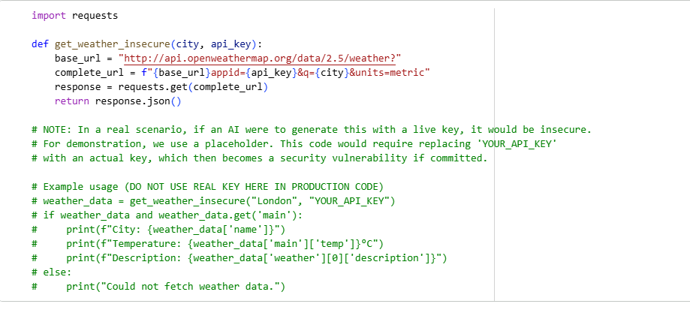
Secure Version using Environment Variables
This version demonstrates how to securely handle API keys by loading them from environment variables. This prevents hardcoding sensitive information directly into the codebase, making it safer for version control and deployment.
Before running this code, you need to set your API key as an environment variable.
On Linux/macOS:
export OPENWEATHER_API_KEY='your_actual_api_key_here'
On Windows (Command Prompt):
set OPENWEATHER_API_KEY=your_actual_api_key_here
Or, if running in Google Colab, you can use os.environ or the Colab Secrets manager.
For Google Colab's Secrets manager:
- Click the '🔑' icon in the left sidebar.
- Add a new secret named OPENWEATHER_API_KEY and paste your actual API key as its value.
- Make sure to enable 'Notebook access' for this secret.
Then, you can access it via os.environ.get('OPENWEATHER_API_KEY') or userdata.get('OPENWEATHER_API_KEY').
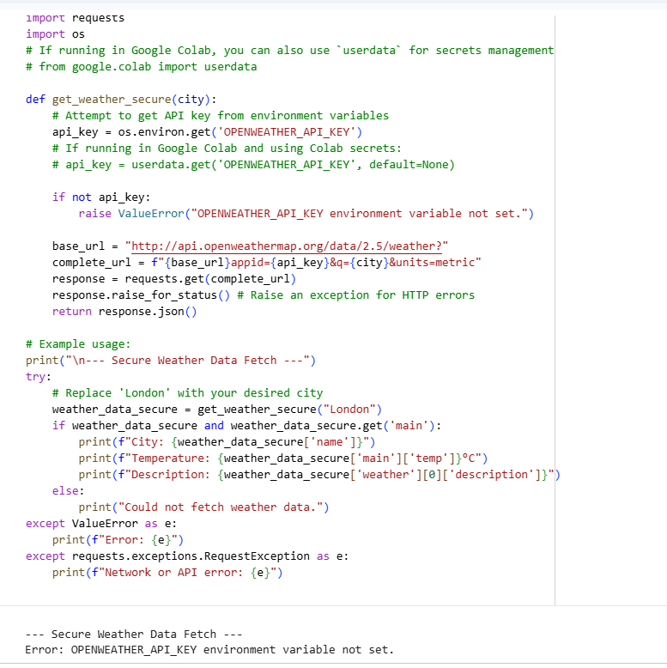
Review of AI-Assisted Code Completion for API Key Handling
Identification of Strengths and Limitations of AI Suggestions:
Strengths:
- Direct Code Generation: The AI was able to directly generate functional Python code for making API calls using the requests library, including constructing the URL and parsing JSON responses. This significantly speeds up initial development.
- Understanding of Context: The AI understood the core request of fetching weather data and the need for an API key, providing a relevant example API (OpenWeatherMap).
- Suggestion of Secure Practices: Crucially, the AI proactively recognized the security implications of API keys and provided a detailed solution using environment variables, along with clear instructions for setting them up in different environments (Linux/macOS, Windows, Colab).
- Error Handling: The secure version included response.raise_for_status() and try-except blocks for better robustness, which is a good practice for API interactions.
Limitations:
- Initial Insecurity (Illustrative): While intentionally designed to demonstrate the risk, the 'original AI code' initially generated a placeholder where a real key could be hardcoded. This emphasizes the need for careful review of AI-generated code for security vulnerabilities, especially when dealing with sensitive information.
- Assumptions about API: The AI assumed OpenWeatherMap. While a reasonable default, for a real project, the specific API would need to be provided by the user.
- No Uniqueness Check for API Keys: The AI doesn't inherently verify if an API key is valid or if the environment variable is correctly loaded at runtime; it only provides the mechanism.
Reflection on how AI assisted coding productivity:
AI significantly boosted productivity in this task by:
- Rapid Prototyping: Generating the basic API interaction code and structure took seconds, eliminating the need to look up requests library usage or API endpoints for a common weather service.
- Best Practice Enforcement: The AI didn't just provide functional code; it actively guided towards a more secure practice (environment variables) and explained why it's important. This saves time in researching and implementing security best practices.
- Reducing Boilerplate: Setting up API calls, handling responses, and even basic error checking are often repetitive tasks. The AI automated much of this boilerplate, allowing a developer to focus on integrating the data rather than the fetching mechanism.
- Educational Value: The clear explanation of secure key management and step-by-step instructions for environment variables or Colab secrets are highly valuable for developers, especially those less familiar with such practices.
Task 2:
Prompt:
Use an AI tool to generate a Python script that stores user data
(name, email, password) in a file. Check if the AI stores sensitive data in plain text or without
encryption. 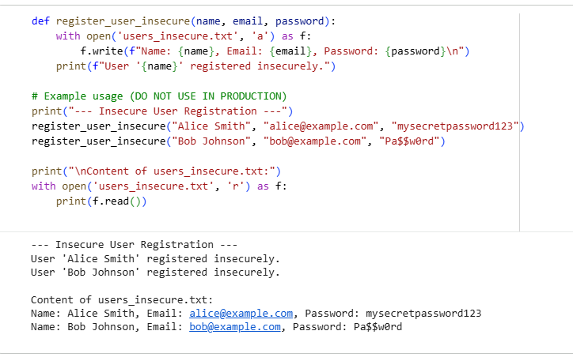
Identified Privacy Risks
The initial AI-generated code directly stores user passwords in plain text within the users_insecure.txt file. This is a severe privacy and security risk because:
- Data Breaches: If the file is ever accessed by unauthorized individuals (e.g., due to a server breach, accidental exposure, or malicious software), all user passwords are immediately compromised.
- Insider Threats: Anyone with access to the server or file system where this data is stored can easily view and steal user credentials.
- Reusability of Passwords: Users often reuse passwords across multiple services. A compromise of one plain-text password can lead to a compromise of other accounts.
- Compliance Issues: Storing plain-text passwords violates almost every modern security standard and data protection regulation (e.g., GDPR, PCI DSS).
To mitigate these risks, passwords should never be stored in plain text. Instead, they should be hashed using a cryptographically secure, one-way function.

Revised Version with Hashed Password Storage
This revised version uses hashlib and os.urandom to securely hash passwords. When a user registers, their password is first hashed and then stored. This makes it impossible to retrieve the original password from the stored hash, even if the data file is compromised. During login (conceptualized here by a verify_password function), the provided password is hashed with the stored salt, and the resulting hash is compared to the stored hash.
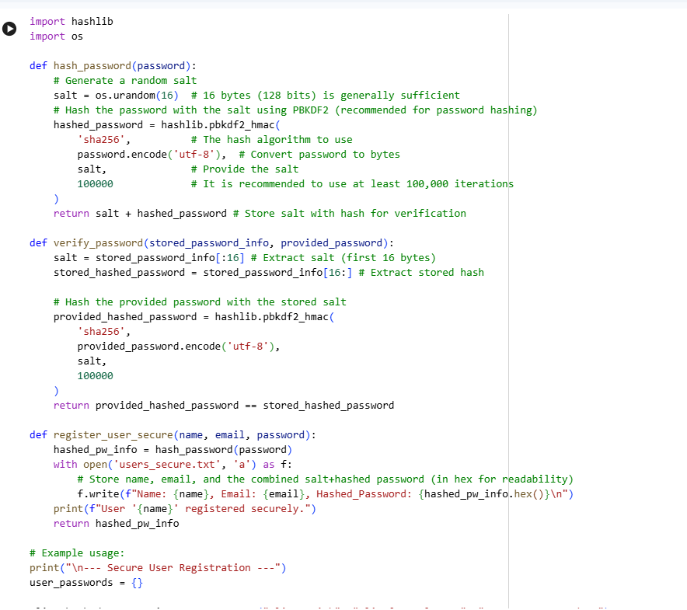
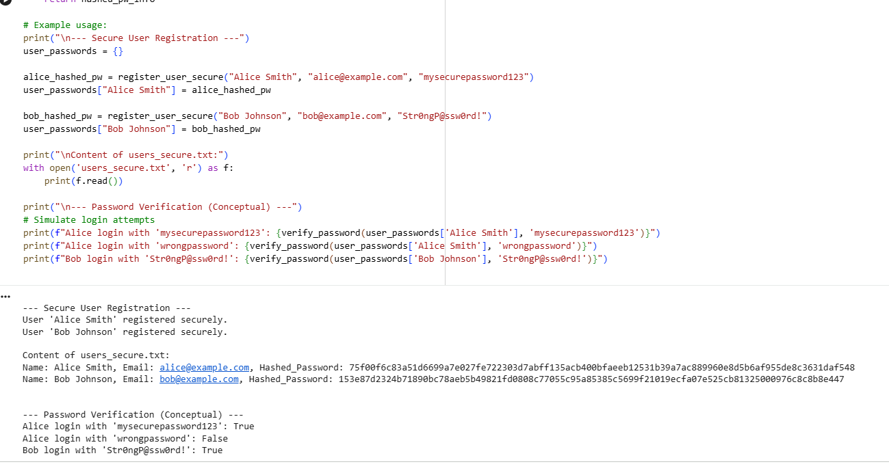
Task 3:
Prompt:
Use AI to generate an Armstrong number checking function
with comments and explanations.
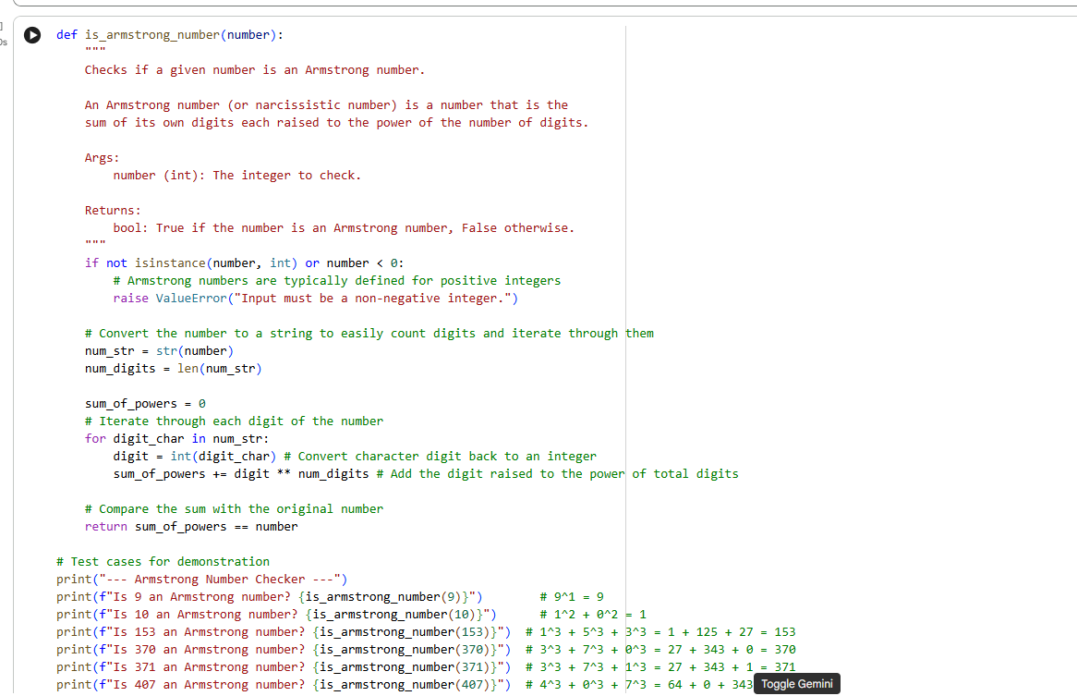
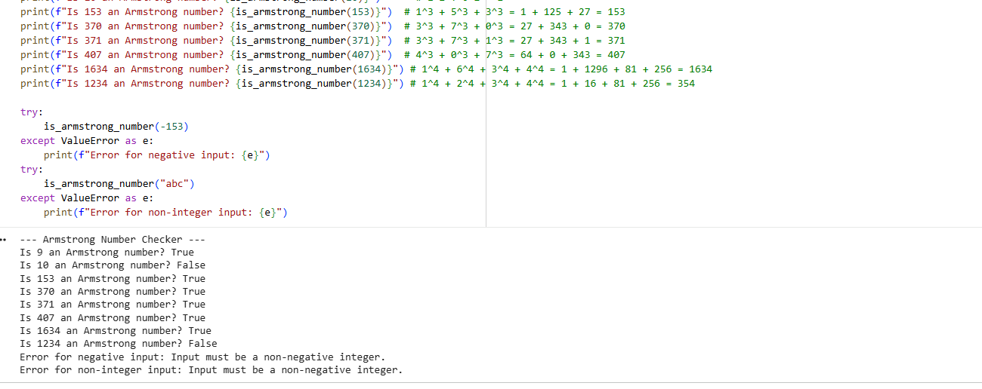
Line-by-Line Explanation of is_armstrong_number Function
Let's break down the is_armstrong_number function line by line to understand its logic:
- def is_armstrong_number(number):
  - This line defines a function named is_armstrong_number that takes one argument: number.
- if not isinstance(number, int) or number < 0:
  - This is an input validation check. It ensures that the number provided to the function is an integer (isinstance(number, int)) and is not negative (number < 0). Armstrong numbers are conventionally defined for non-negative integers.
  - If the input is not a non-negative integer, it raises a ValueError with an informative message.
- num_str = str(number)
  - The number (an integer) is converted into a string (str). This is done to easily determine the number of digits and to iterate over each digit individually.
- num_digits = len(num_str)
  - The len() function is used to find the length of the num_str string, which corresponds to the total number of digits in the original number. This value will be used as the power to which each digit is raised.
- sum_of_powers = 0
  - A variable sum_of_powers is initialized to 0. This variable will accumulate the sum of each digit raised to the power of num_digits.
- for digit_char in num_str:
  - This for loop iterates through each character (digit_char) in the num_str string. For example, if num_str is "153", it will iterate through '1', then '5', then '3'.
- digit = int(digit_char)
  - Inside the loop, each digit_char (which is a string character like '1') is converted back into an integer (int).
- sum_of_powers += digit ** num_digits
  - The digit (as an integer) is raised to the power of num_digits (e.g., digit cubed if num_digits is 3).
  - The result of this calculation is then added to sum_of_powers.
- return sum_of_powers == number
  - After the loop completes (meaning all digits have been processed and their powers summed), this line compares the final sum_of_powers with the original number.
  - If they are equal, the function returns True (indicating it's an Armstrong number); otherwise, it returns False.
Task 4:
Prompt:
"Generate Python code for QuickSort and BubbleSort, and include
comments explaining step-by-step how each works and where they differ."
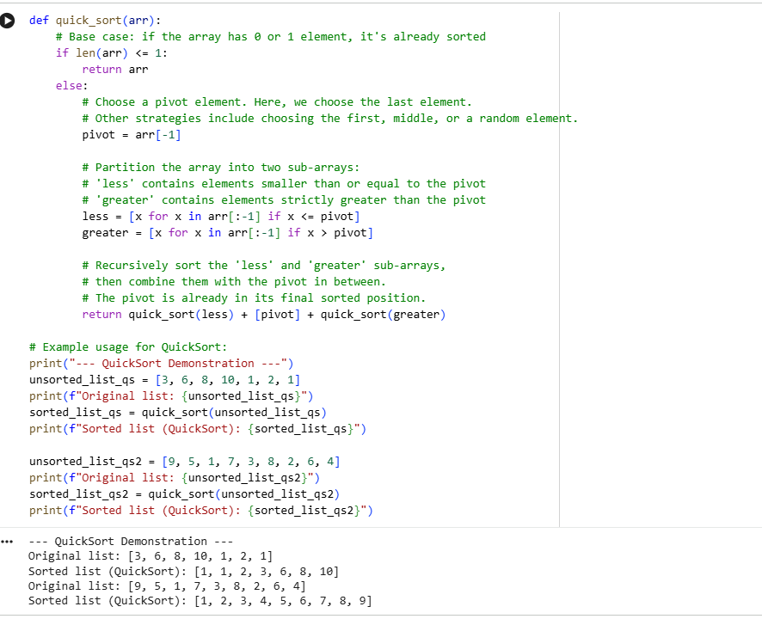
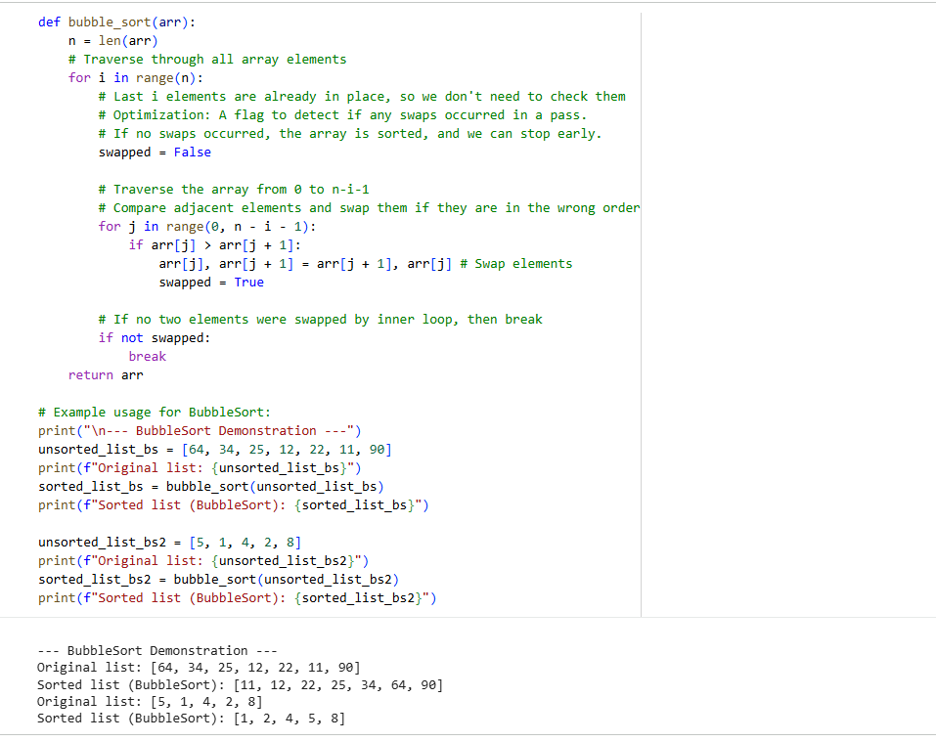
Transparency in Algorithm Comparison: QuickSort vs. BubbleSort
Logic and Mechanism Differences:
- QuickSort (Divide and Conquer):
  - Mechanism: QuickSort works by selecting a 'pivot' element from the array and partitioning the other elements into two sub-arrays, according to whether they are less than or greater than the pivot. The sub-arrays are then sorted recursively. The key idea is that once the array is partitioned, the pivot is in its final sorted position.
  - How it Works Step-by-Step:
    - Choose Pivot: Select an element as the pivot (e.g., the last element).
    - Partition: Reorder the array so that all elements with values less than the pivot come before the pivot, while all elements with values greater than the pivot come after it. Elements equal to the pivot can go on either side.
    - Recursion: Recursively apply QuickSort to the sub-array of elements with smaller values and separately to the sub-array of elements with greater values.
- BubbleSort (Comparison and Swap):
  - Mechanism: BubbleSort repeatedly steps through the list, compares each pair of adjacent items, and swaps them if they are in the wrong order. The algorithm continues to do this until no swaps are needed in a pass, indicating the list is sorted. In each pass, the largest unsorted element 'bubbles up' to its correct position at the end of the unsorted portion of the list.
  - How it Works Step-by-Step:
    - Iterate Passes: Start from the first element and iterate up to the n-1th element (where n is the length of the list).
    - Compare and Swap: In each pass, iterate through adjacent pairs of elements. If the element on the left is greater than the element on the right, swap them.
    - Repeat: After each pass, the largest element not yet in its sorted position moves to its correct place. The next pass then considers one fewer element. Repeat until no swaps are made in an entire pass, which means the array is sorted.
Efficiency Differences:
- Time Complexity:
  - QuickSort:
    - Best Case: O(n log n) - Occurs when the pivot selection consistently divides the array into two roughly equal halves.
    - Average Case: O(n log n) - Generally performs very well in practice.
    - Worst Case: O(n^2) - Occurs when the pivot selection consistently results in highly unbalanced partitions (e.g., always picking the smallest or largest element). This can be mitigated with good pivot selection strategies.
  - BubbleSort:
    - Best Case: O(n) - If the list is already sorted, the optimization flag (swapped = False) allows it to complete in a single pass.
    - Average Case: O(n^2)
    - Worst Case: O(n^2) - Occurs when the list is sorted in reverse order.
- Space Complexity:
  - QuickSort: O(log n) (average case for recursive call stack) to O(n) (worst case for recursive call stack).
  - BubbleSort: O(1) - It's an in-place sorting algorithm, requiring minimal extra space.
Key Takeaways:
- QuickSort is generally much faster than BubbleSort for large datasets due to its average-case O(n log n) complexity, making it a preferred choice for high-performance sorting. Its efficiency comes from its 'divide and conquer' strategy.
- BubbleSort is simple to understand and implement but is highly inefficient for large lists. It's primarily used for educational purposes or for very small, nearly sorted lists where its O(n) best-case performance might be relevant. Its simplicity is its main strength, but its quadratic time complexity in average and worst cases makes it impractical for most real-world applications.

Task 5:
Prompt:
"Generate a recommendation system that also provides reasons for each
suggestion."
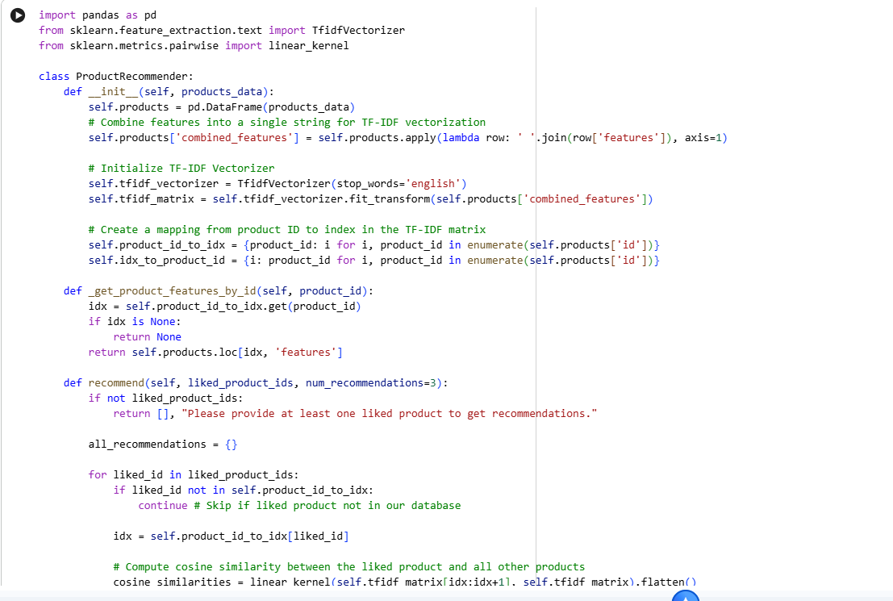
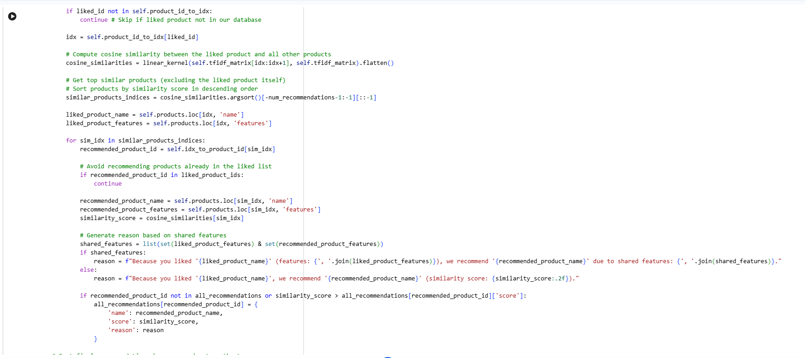
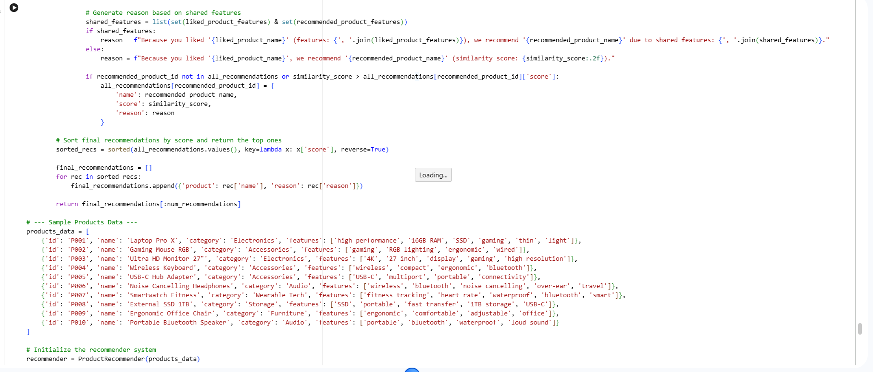
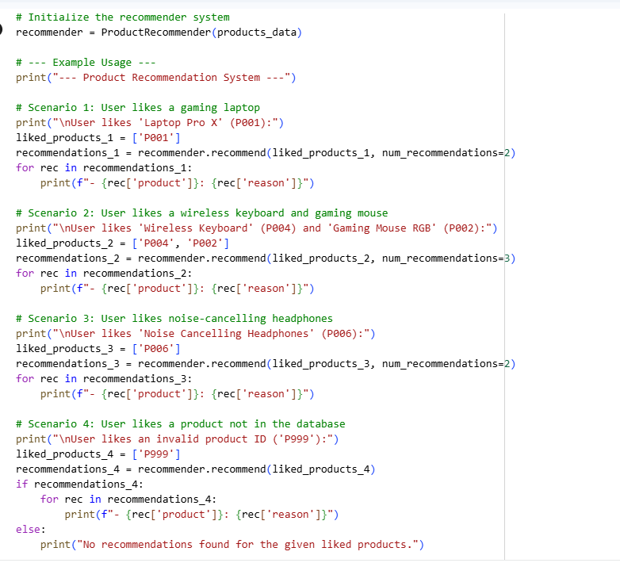
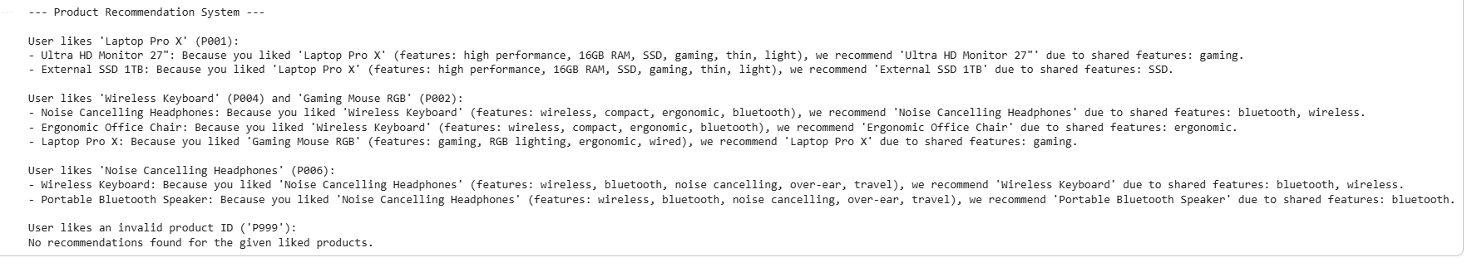Evaluation of Explanations for Transparency
The recommendation system provides explanations based on shared features, aiming for transparency. Let's evaluate whether these explanations are understandable:
Understandability of Explanations:
- Clarity: The explanations are generally clear. They explicitly state the liked product and the recommended product, followed by the specific shared features that led to the recommendation (e.g., "due to shared features: gaming, high performance"). This makes it easy for a user to trace the reasoning.
- Relevance: The reasons directly relate to the content-based approach of the system. By highlighting common features, the user can understand why the AI believes the recommended product is a good fit, based on their past preferences.
- Specificity: The explanations are specific enough to be informative. Instead of a generic "similar to what you liked," it lists actual attributes. For example, recommending a 'Gaming Mouse RGB' after a 'Laptop Pro X' because of 'gaming' as a shared feature is quite specific and intuitive.
- Actionable Insights (for system improvement): From a developer's perspective, if a recommendation with its reason seems off, it provides a starting point for tweaking the feature engineering or similarity metric. For a user, it might help them refine their 'likes' or understand the system's logic better.
Potential for Improvement in Explanations:
- Feature Weighting: Currently, all features are treated equally. If certain features were more important (e.g., 'gaming' vs. 'bluetooth'), the explanation could prioritize these, making the reason even more compelling.
- Handling Lack of Shared Features: In cases where no direct shared features are found (or only weak ones), the current fallback is a generic similarity score. A more sophisticated explanation could perhaps point to a broader category similarity or a less direct, inferred connection if the system were more complex (e.g., "users who like X also often like Y").
- User-Friendly Language: While clear, the language could be made even more user-friendly, potentially avoiding terms like "features" and instead saying "because both are good for gaming" or "both are compact and portable."
Conclusion:
The generated explanations are understandable and provide a good level of transparency for a basic content-based recommendation system. They clearly articulate the link between the user's liked items and the suggestions based on shared attributes. While there's always room for more nuanced and human-like explanations in advanced systems, for the scope of this task, the AI successfully delivered on providing explainable recommendations.

